IMPORTANT ANNOUNCEMENT!
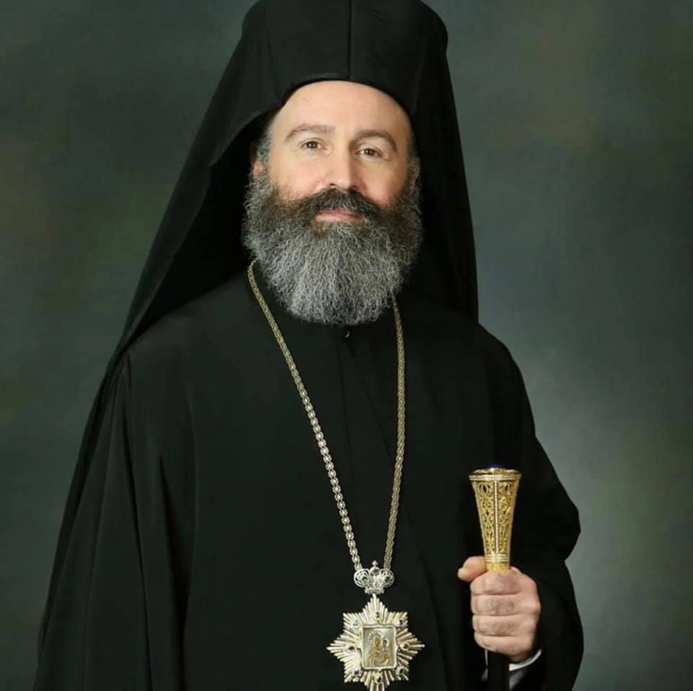
Your Graces, beloved fathers and beloved children,
With pain of soul, but at the same time, with a sense of pastoral responsibility on a sensitive matter which concerns public health, I communicate to you that, due to the extraordinary measures that the Federal Government of Australia took to restrict the spread of the Coronavirus, we are compelled to suspend public worship in our Churches.
This means that from today our Churches will remain closed to the faithful. However, all Services, the feast days of the Saints, and the Divine Liturgies will be conducted only by the Priest and the Chanter. Sacraments and funerals will continue to take place but only in the presence of the immediate family members.
During these difficult times for all of humanity and especially for our country Australia, I urge you to show understanding, unity and confidence both in the Leadership of our Nation and towards our Holy Archdiocese. I call upon you all to pray more. I ask that you place your trust in God. It is a trial that we are experiencing, but we Orthodox know very well that after the Crucifixion comes the Resurrection.
There is need for patience, unity and collaboration. Resurrection will come soon. With love in Christ,
In Sydney, on the 19th day of March 2020,
Your Archbishop
† MAKARIOS of Australia

